FEASIBILTY INVESTIGATION

RE-USE OF CHAPELS AT GREEN LANE, HALE AND WEST STREET

JUNE 2012

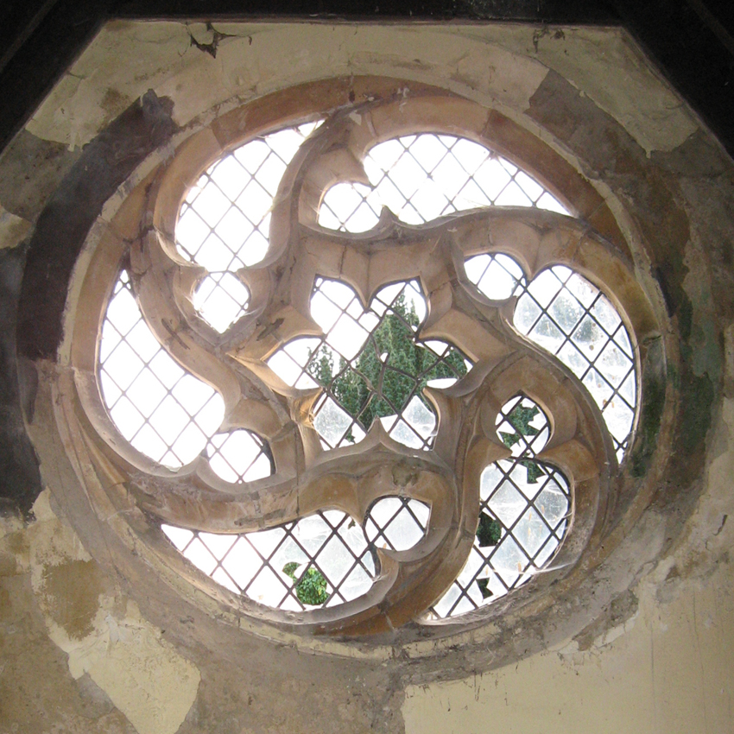

CRANE & ASSOCIATES

52 High Street Esher Surrey KT10 9QY
01372 470524

1 Objectives and Scope
The objectives of the feasibility assessment are as follows
• assess the existing condition of each Chapel
• consider alternative viable uses for each Chapel
• assess the planning and conservation issues involved
• assess the amount of work required by Farnham Town Council
to either let or dispose of each site
• assess the costs involved in enabling works to let or dispose of each site
• assess the end value of each site

2 Consultants
The following consultants have contributed to the feasibility assessment
• Architect Robin Crane Crane Associates
• QS David Payne Payne Cole
• Surveyor Tim Chetwood CLM
• Engineer Gary Holt Construction Design Partnership
• Valuers Peter Miller Wadham & Isherwood

3 Site Evaluation
Tim Chetwood of Chetwood Lawton and Morrison has surveyed the Chapels for Farnham Town Council in 2006. A further inspection was undertaken in May 2012, to update the previous report and assess if the condition had deteriorated in the intervening period.

TC’s full update report is attached as Appendix 1.

Gary Holt (structural engineer) of Construction Design Partnership has also assessed the Chapels. His assessment is attached as Appendix 2.

3.1 Summary of Conditions
Below we have summarised the current condition of each site. See Appendices 1 and 2 for detailed reports.

Hale
The buildings are in a very poor state of repair.

4 Proposed Uses
The proposed uses are as follows

Hale School annex
Community use
Mausoleum

5 Planning and Conservation
The proposed uses have been discussed with Waverley.

5.3 Hale
We have had verbal discussions with Tim Lipscomb at Waverley (13th June 2012) regarding a change of use to a school annex, community use or mausoleum.

Planning No objection in principle
Conservation No objection in principle

6 Build Costs
David Payne has assessed the build costs for each site as follows

Hale
Basic structural repair & remedial works £99,177.65
Refurbish and extend – Classroom option £239,773.60
Ditto – Community use option £236,627.60

See separate document for a detailed breakdown of costs

7 Valuations
Awaiting report from Peter Miler, Wadham and Isherwood

8 Deconsecration Procedure
Procedure to be confirmed by the Registry Office of the Bishop of Guildford
Contact the Bishop’s Chaplin Mark Heather 01483 590500

Firstly it is necessary to establish if the Chapels and cemeteries are ‘Consecrated’ or ‘Dedicated’. They are likely to be consecrated.

The next step is to locate written evidence of consecration. This should either be with the title deeds or in the archives of the Diocesan Registry. A Deed of Deconsecration is then prepared by either the Diocesan lawyers Lee Bolton Molier Williams, or the owners, Farnham Town Council. The Chaplin recommends that if FTC draws up the Deed they refer to LBMW.

The Bishop will need to agree to the deconsecration, but is unlikely to disagree given the circumstances.

It is not possible to grant Rights of Way across consecrated land, i.e. for access to West Street or Hale (if the cemeteries are consecrated), although it is possible to grant a licence for access.

Appendix 2

Structural Engineer’s Assessment
May 2012
Gary Holt of Construction Design Partnership

Hale
Summary
Poor condition
Roof repairs required (re-roof??)
Bowed walls to be stabilised (by new roof)
Sort out external ground/drainage.

Roof
• Poor condition – tiles broken in some areas – timber under gone – rafters??

Walls
• No significant cracking noted but walls badly bowed (roof spread).
• Externally brickwork/flint generally OK.
• Internally plaster in poor condition, exposed brickwork in poor condition (breaking up).

Floors
• Level – no significant distress.

External
• Similar situation as other chapels (see West Street notes).

Appendix 3
Conservation Officer’s Comments

Site Visits 4th April 2012

The Hale chapels are the most dilapidated and I would hope that the town council will look at these as soon as possible. The proposal for a annex to the school is one I would be happy to consider although I appreciate that this does depend on the school’s willingness to take them on. The community use may be something that could be worked in with St Mark’s Church across the road. The idea of linking the two buildings is acceptable in principle. I would be happy to consider a contemporary approach as suggested by the initial drawings.

